Lab Report 6

*Name: Sricharan Vinoth Kumar*

*Roll no: 2024112022*

*Group no: 10*

Experiment 1:-

* Objective:

To create a S-R Latch using NOR gates and observe its function.

* Electronic Components Required:
  + 7402 2-input NOR gate IC
  + Digital Test Kit
* Reference Circuit:-

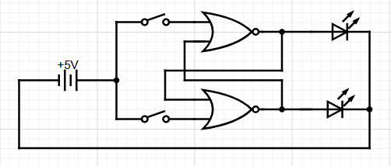

* Procedure:-
  1. Ensure that the input pins IP1-12 and output LEDs LG1-12 and LR1-12 are working.
  2. Using a 2-input NOR gate IC, assemble an SR latch as shown in the circuit diagram.
  3. Apply all possible inputs of R and S to the latch and observe the outputs in each case.
  4. Tabulate the observations and verify the function of the S-R latch.
* Observation:-

Function table of the circuit,

|  |  |  |
| --- | --- | --- |
| S | R | Q(t+1) |
| 0 | 0 | Q(t) (Memory state) |
| 0 | 1 | 0 (Reset) |
| 1 | 0 | 1 (Set) |
| 1 | 1 | Forbidden |

* Conclusion:-

An S-R latch using NOR gates has been assembled and its function has been observed.

* TinkerCAD Simulation:-

<https://www.tinkercad.com/things/5X1xLI4e2QS-dsm-lab-6-exp-1?sharecode=LkADH9MJCZeNb_d3srh3YiamyXwN9jUDJuAE9Fspz9Q>

Experiment 2:-

* Objective:-

To create a J-K Flip Flop and observe its function.

* Electronic Components Required:-
  1. 7420 4-input NAND gate IC
  2. 7400 2-input NAND gate IC
  3. 7402 2-input NOR gate IC
  4. Digital Test Kit
* Reference Circuit:-

* Procedure:-
  1. Ensure that the input pins IP1-12 and output LEDs LG1-12 and LR1-12 are working.
  2. Set the CLOCK of the kit to SLOW mode or Manual mode.
  3. Using the above-mentioned ICs, assemble the circuit as per the given circuit diagram.
  4. Apply all possible combinations of J and K and observe the outputs.
  5. Tabulate the observations and verify the function of the J-K Flip flop.
* Observation:-

Observed characteristic table of the circuit,

|  |  |  |
| --- | --- | --- |
| J | K | Q(t+1) |
| 0 | 0 | Q(t) |
| 0 | 1 | 0 |
| 1 | 0 | 1 |
| 1 | 1 | Q’(t) |

* Conclusion:-

A J-K Flip flop has been assembled and its function has been observed.

* TinkerCAD Simulation:-

<https://www.tinkercad.com/things/cCOD9E9mK0A-dsm-lab-6-exp-2?sharecode=zkHdzxTSTKf0m-X_W__gAmhNmPn6RYiz2QeUedzCtbU>

Experiment 3:-

* Objective:-

To design a 4 – bit binary counter using Arduino

* Electronic Components Required:-
  + Arduino Uno
  + Digital Test Kit
* Reference Circuit:-

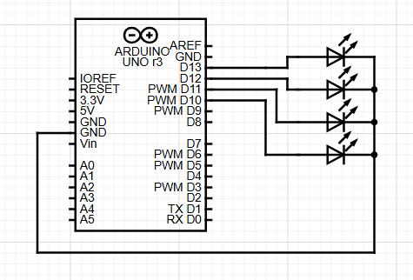

* Procedure:-
  1. Connect the Arduino to 4 output LEDs as per the given circuit diagrams.
  2. Write a program to oscillate the output level of the pins, such that each pin has twice the time period of its adjacent pin.
  3. Upload the code and observe the output
* Observation:-

Code of the program,

#include "Timer.h"

Timer t;

int pin1 = 7;

int pin2 = 6;

int pin3 = 5;

int pin4 = 4;

void setup() {

  pinMode(pin1, OUTPUT);

  pinMode(pin2, OUTPUT);

  pinMode(pin3, OUTPUT);

  pinMode(pin4, OUTPUT);

  t.oscillate(pin1, 8000, LOW);

  t.oscillate(pin2, 4000, LOW);

  t.oscillate(pin3, 2000, LOW);

  t.oscillate(pin4, 1000, LOW);

}

void loop() {

  t.update();

}

* Conclusion:-

A 4-bit counter has been successfully assembled using the Arduino.

* TinkerCAD Simulation:-

TinkerCAD does not support the Timer.h library used in the program. Therefore, the code used in the simulation is different. But the basic idea is the same.

<https://www.tinkercad.com/things/ca3EYNGTRjL-dsm-lab-6-exp-3?sharecode=EKSB2RT2Bv1hWBuRSv4DTtsvnatSO2Al-Q6kosErUPE>